Design below page using tailwind-css or any other library
Login Page
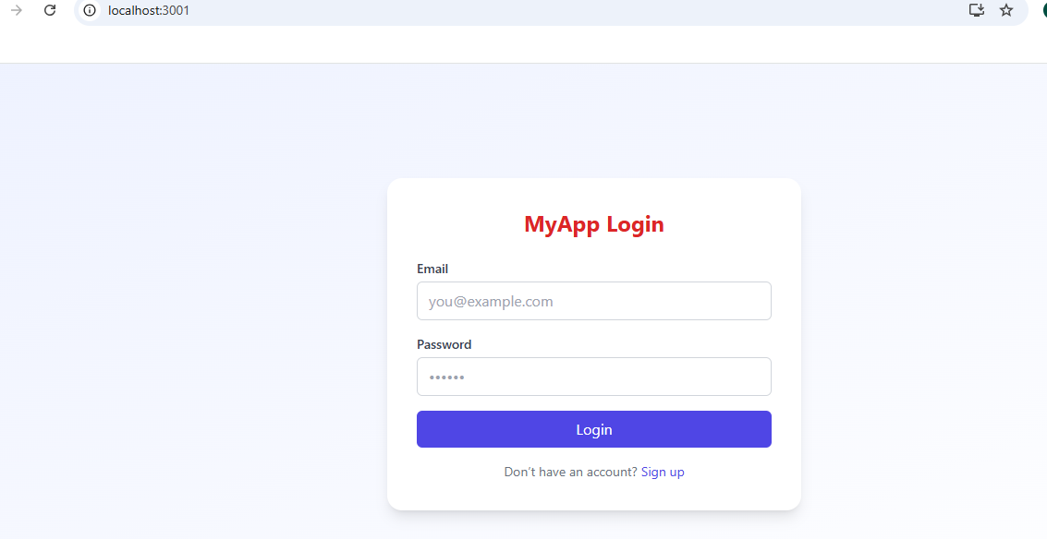
Click on Login button Just match user ID: you@example.com password: admin@123
Popup message like below
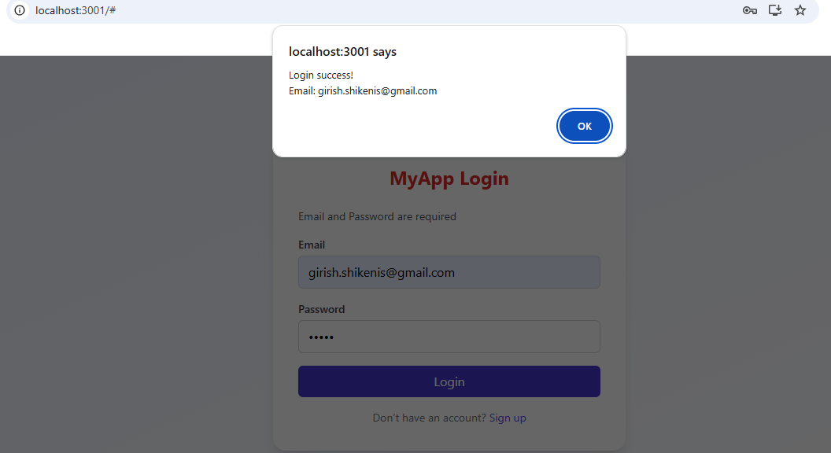

Click on Sign up
